**Task 1.2:**

First, we simplify this equation:

Then we divide by the complex number , where , to get the next position.

With this,

We see that with each movement, the power decreases by 1, and since we are dividing by the complex number , we can also calculate the angle it is being rotated by.

Using,

Every time we divide by the complex number , we rotate 45° around the origin.

A rotation of 45° means it takes to get back to the initial position, and since she moves 64 times, to get back to the initial position.

**Using 8 movements as an example (64 would yield the same results):**

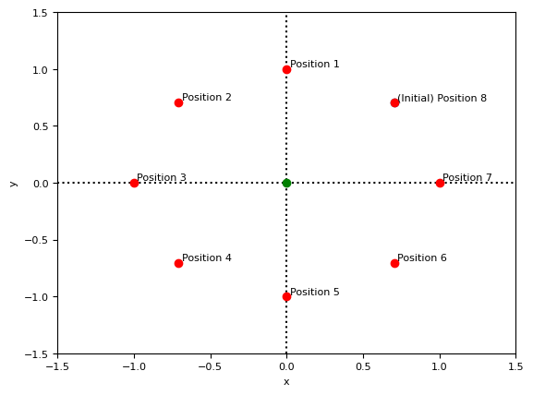

Since dividing a position by the complex number gives us the next position, dividing by it 8 times, multiple times will give us an equivalent position, but one where we can do feasible calculations to get the (Re, Ima) coordinates for each movement:

When it comes to adding up all her movements, since she is moving in a circular motion, the total will give us a coordinate at the origin (0,0) and dividing it by the total amount of moves gives us the same answer.

**0 + 1j + 0.7071 + 0.7071j + 1 + 0j + 0.7071 - 0.7071j + 0 – 1j - 0.7071 - 0.7071j - 1 + 0j - 0.7071 + 0.7071j**

**= 0/8 (Mean)**

**= 0**

**Task 2.2:**

First, we simplify this equation:

Again, we can get the next position by dividing by the complex number ,

Here we see that every time we divide by , the exponents of and go down by 1.

Since she moves in the exact same way as **Task 1**, we know that she rotates 45° around the origin every move.

Which means to get to the same coordinates as in **Task 1**, she needs to move until the mean of all her movements gives us the coordinate at the origin.

**Task 3.2:**

Looking at the limit from both sides we get:

, dominates, so we can ignore everything besides it

, dominates, so we can ignore everything besides it

Since the limits vary from both sides, that means the limit as x approaches 3 does not exist (NaN), therefore you should press the Big Red Button.

**Task 4.2:**

First, we turn this implicit equation into a function of :

Then, we set the expression inside the square root to be non-negative

i.e.

We know that the safe positions are only going to consist of positive values, otherwise they will go into complex numbers.

We solve the numerator,

The numerator indicates that the graph intersects the x-axis at 0 and 40.

We then solve the denominator,

The denominator indicates that when x equals 80, a divide by 0 occurs; the graph heads towards +inf, therefore not being a safe position.

From this we can say the domain of the function is

**Task 5.2:**

To start, we must fill in the spots in the multiset (allows duplicate values):

First, the combinations:

Second, the permutations:

Third, the limit:

Different limits on both sides, therefore limit does not exist (NaN)

Task 3’s answer is NaN, so the final multiset is now:

Now, we find the states of , and :

Now we can evaluate ,

True, therefore choose the left lift.